Water-Quality and Cyanotoxin Results
Most water quality parameters did not significantly change from August to October (see Caddo data table file). Most nitrogen was in organic forms and between 37 and 42% was in the dissolved organic phase. Total phosphorus concentrations were < 1.0 mg/L during both surveys. Generally, nutrient (nitrogen and phosphorus) concentrations did not significantly change from August to October. Chlorophyll and phycocyanin concentrations increased between the two surveys based on sonde measurements and lab analyses. The parameters with the most significant changes were manganese and geosmin. Manganese increased from 0.90 ug/L to 26.2 ug/L and Geosmin increased from 8.0 ng/L to 18.1 ng/L.
Cyanotoxin results for anatoxin-a (neurotoxin, known as very fast death factor), cylindrospermopsin (hepatotoxin), and microcystin (hepatotoxin) via rapid-assessment dipstick kits were negative. Cyanotoxin result for microcystin via ELISA was 0.15 µg/L for the sample collected on August 23, 2018. This value is less than the U.S. EPA 10-day health advisory level for human consumption of finished drinking water for children less than six years old (0.3 µg/L) and less than the Unregulated Contaminant Monitoring Rule 4 for public water systems (0.3 µg/L). Microcystin results were less than the laboratory reporting level (LRL) for the sample collected on October 4, 2018. Cyanotoxin results for anatoxin-a, cylindrospermopsin, and saxitoxin (neurotoxin, best-known paralytic shellfish toxin) via ELISA were less than the LRLs.

Phytoplankton Results
Total number of species increased from 54 to 64 phytoplankton species from August to October. For both samples, the phytoplankton community was dominated by Cyanophyta followed by Chlorophyta, in terms of biovolume and number of species. Haptophyta, specifically Chrysochromulina parva, was the only phytoplankton division present in August but not in October. In August, the most common species by a large margin were Pseudanabaena limnetica and Cylindrospermopsis raciborskii (22.4% and 19.6% of total biovolume, respectively). Cylindrospermopsis raciborskii is a known bloomer and can produce cylindrospermopsin, anatoxin-a, and saxitoxin. In October, Cylindrospermopsis raciborskii biovolume dropped to 2.1% and was replaced by Cryptomonas erosa (17.8% of total biovolume) as the second most dominant species. Pseudanabaena limnetica remained the most abundant species with 24.7% of total biovolume in October.

HABs and CyanoHABs Results
Although a bloom was not detected during the surveys, several genera and species (most notably Cylindrospermopsis raciborskii) were present that can bloom if conditions are favorable for proliferation of cyanobacteria. These conditions are most commonly stagnation, high temperatures, and excessive nutrient loadings.
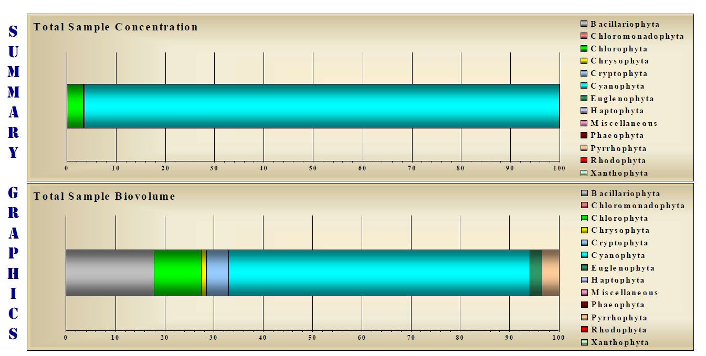
Figure 1: Phytoplankton community composition for August 23, 2018 (54 phytoplankton species). Graphics by PhycoTech
Phytoplankton Summary for August 23, 2018
(Division) (# species within division) (percentage of total biovolume)
Cyanophyta (22 species) 61.05%
Bacillariophyta (4 species) 17.94%
Chlorophyta (18 species) 9.55%
Cryptophyta (1 species) 4.45%
Pyrrhophyta (2 species) 3.45%
Euglenophyta (3 species) 2.46%
Chrysophyta (3 species) 1.05%
Haptophyta (1 species) 0.05%
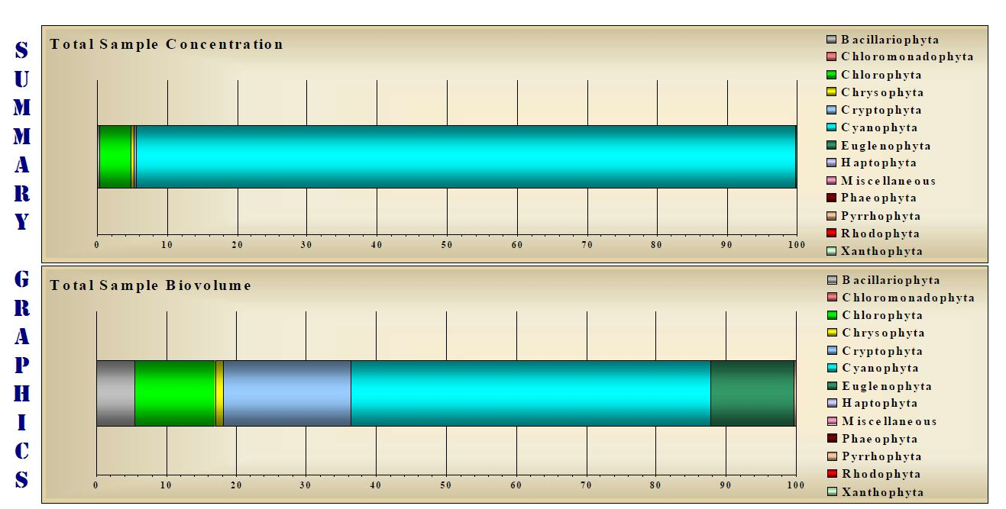
Figure 2: Phytoplankton community composition for October 24, 2018 (64 phytoplankton species). Graphics by PhycoTech
Phytoplankton Summary for October 4, 2018
(Division) (# species within division) (percentage of total biovolume)
Cyanophyta (30 species) 51.53%
Cryptophyta (2 species) 18.12%
Euglenophyta (4 species) 11.83%
Chlorophyta (20 species) 11.51%
Bacillariophyta (5 species) 5.47%
Chrysophyta (2 species) 1.19%
Pyrrhophyta (1 species) 0.34%

